Mantid
PM report to Project Management Board
30th November 2017
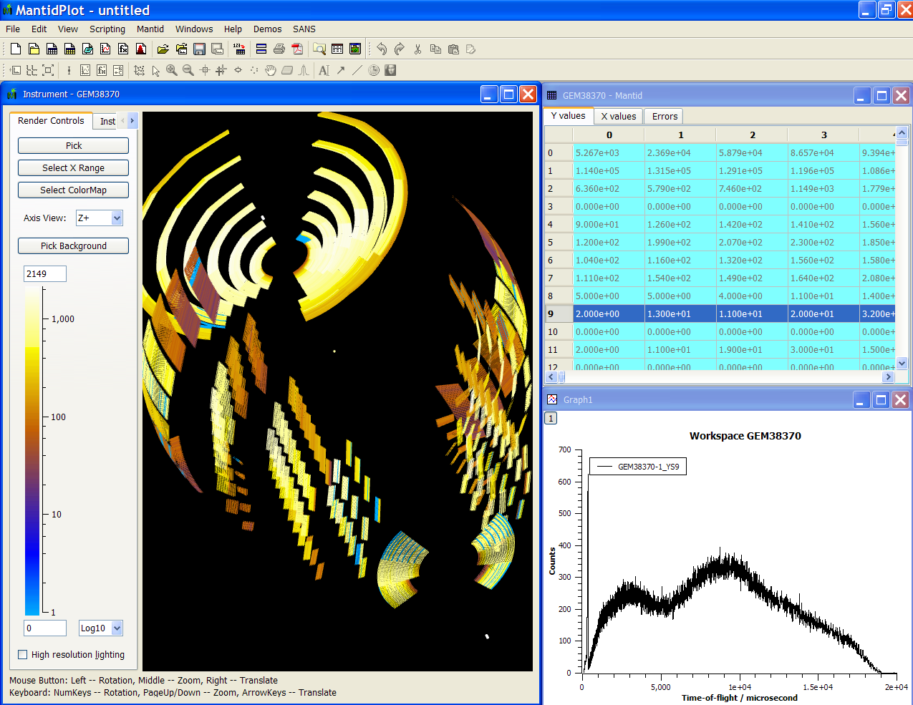
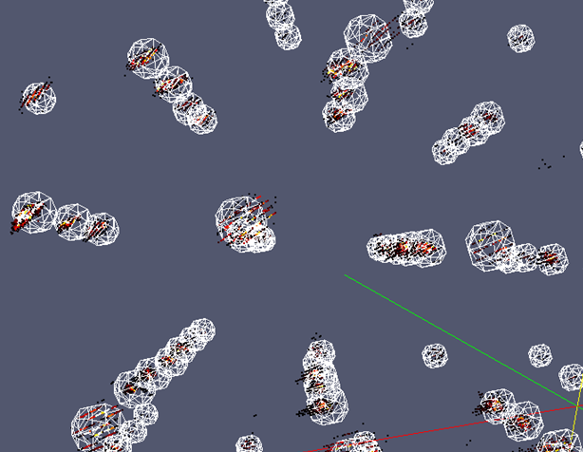
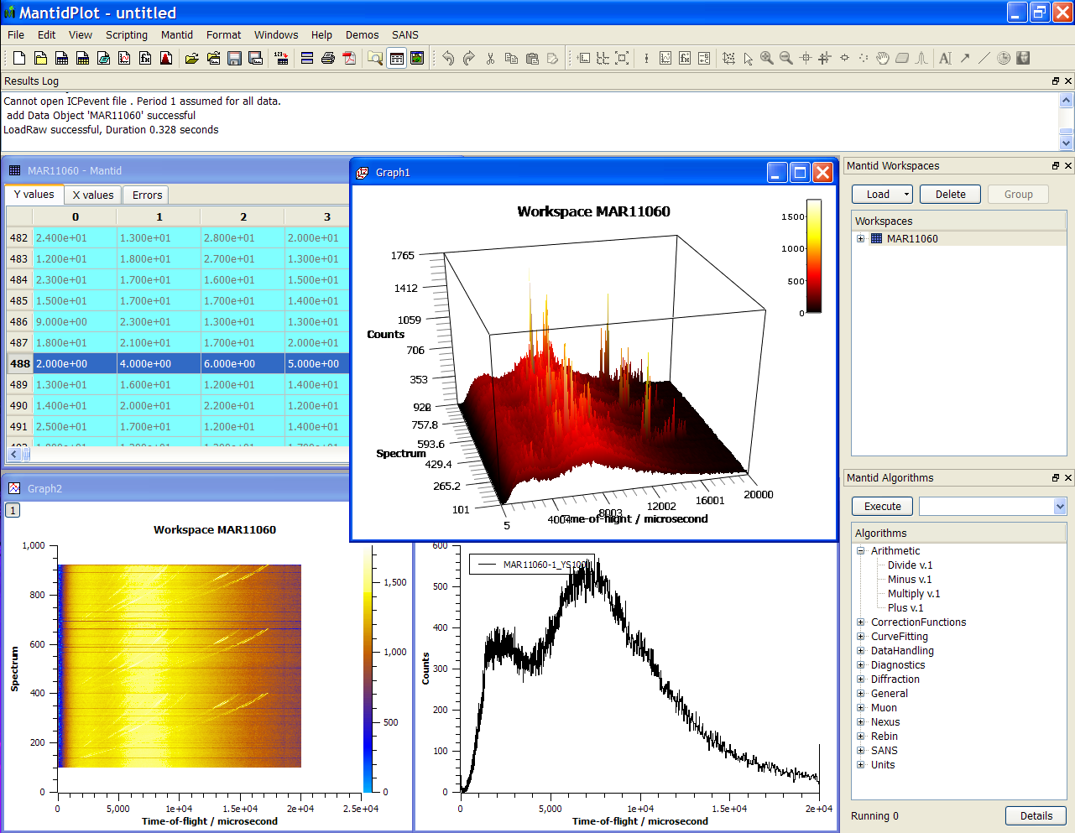
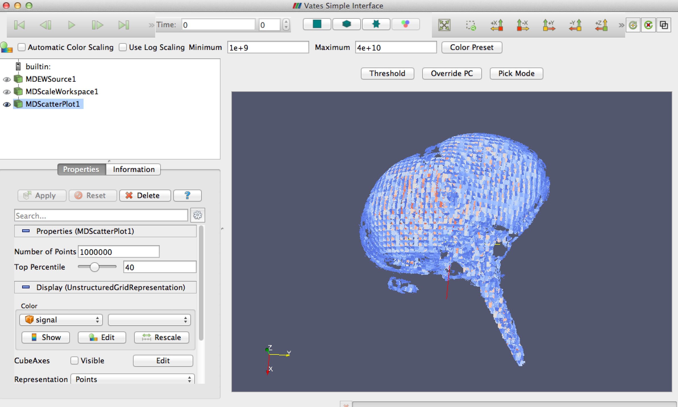
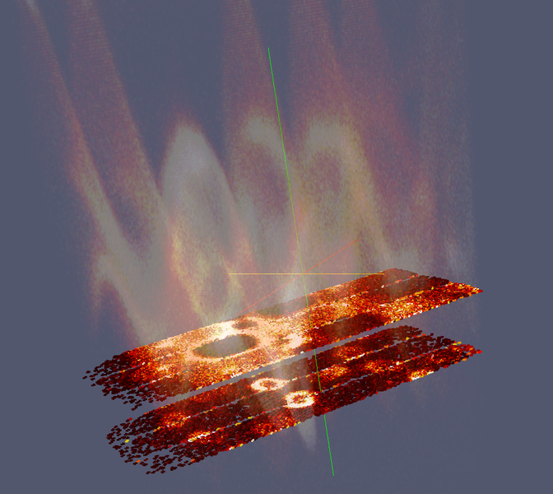
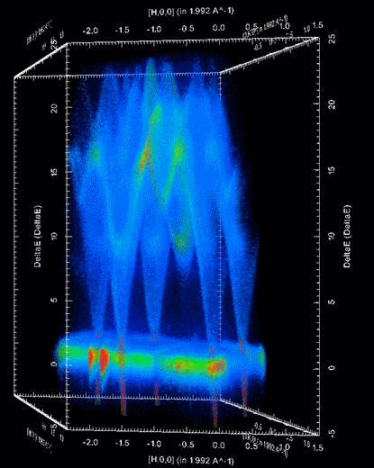

Document Control
This document is under document control. All members of the distribution list will receive updated copies whenever alterations are made. All other copies are uncontrolled.

Contributors
Name | Role | Company
Nicholas Draper | Author | Tessella

Document Approval
Name | Role | Company

Distribution
Name | Role | Company
Project Management Board Members | Recipient | STFC & ORNL
Mantid Project Repository | Filing | STFC & ORNL

Revision History
Author | Issue | Date | Description
Nicholas Draper | V1.R1.M0 | 27-Nov-2017 | 1st version written

References
Document | Ref | Date | Details and Version
Project Specification | [PS] |  | https://github.com/mantidproject/documents/blob/master/Project%20Management/ProjectSpecification.doc?raw=true
Stakeholder Plan | [SP] |  | https://github.com/mantidproject/documents/blob/master/Project%20Management/StakeholderPlan.doc?raw=true
Risk Register | [RR] |  | https://github.com/mantidproject/documents/blob/master/Project%20Management/RiskRegister.xls

Table of Contents
1 Introduction 3
2 Project Documentation 4
3 Project Status 4
4 Usage of Mantid in various Environments 5
5 Future Release Dates 5
6 Core Team 5
7 Progress on Mantid 4.0 6
8 Appendix A: Metrics 7

Introduction

Purpose of this Document
This report details the current state of the Mantid project. The project management board will use this report as an item for discussion at the meeting.

Scope of this Document
The scope of this document is limited to the Mantid project, both for progress up to the meeting of the Project management board, and plans for the future.

Project Documentation
The project documentation is available through the links below. The documents have not been changed since the last PMB meeting.

Stakeholder Plan:
https://github.com/mantidproject/documents/blob/master/Project%20Management/Stakeholder Map.doc?raw=true
No changes this time

Risk Register:
https://github.com/mantidproject/documents/raw/master/Project-Management/RiskRegister.xls
No changes this time.

Project Status

Development Progress
Since the last PM report we have released the following new version of Mantid:

- Release 3.11 – 10th October 2017

The releases were made on time according to plan.

The project metrics in Appendix A.

Usage of Mantid in various Environments
We currently fully support the following environments:
- RHEL 7 64bit
- Windows 7+ 64 bit
- Ubuntu 14.04 64 bit
- Ubuntu 16.04 64 bit
- OS X 10.10+
Limited Support:
Fedora 20

Current Usage:
We currently are not tracking usage metrics, and have not for the last couple of months. This is due to a cloud provider changing their terms and conditions and forcing us to move the database and web interface that records and displays these metrics.

We are in the process of migrating these to our paid for web server, but we will have a gap in our utilisation figures for the time in between.

Future Release Dates
In previous years it has become clear that it is a mistake to try to run a release at the same time as the user or developer workshops. Therefore we propose to delay the code freeze for the next release until the week after the developers have returned from the developers workshop:
- v3.12 26th February 2018
- V3.13 28th May 2018

Core Team
The core team met and each team fed into the discussion any areas that each considered important to consider addressing, this included all the aspects of the ORNL 5 year plan that are still outstanding and relevant. The full list of these items is available here.
Using these items as a starting point representatives from each facility considered which of those aspects should be addressed first. Amalgamating those priorities lead to 3 items that should be addressed by this team to start with.
The first item was passed onto the TSC for immediate design and implementation, the further two require further work in to flesh out the possible approach and cost/benefit details and will be brought to the PMB for discussion when these are ready.

Crash reporting
Automated reporting of crashes and unhandled errors to a central database for quantitative analysis and follow ups for important or repeated situations.
This item was considered to be relatively low effort and closely aligned with the outcomes from the Users workshop that it was immediately delegated to the TSC for design and implementation.

Project Structure: Python vs C++ with extensions
Mantid is currently a C++ project that has a python interface, with this original design Python could be one of many API's or interface languages, however it makes it harder to integrate as well with some aspects of Python. The project could be restructured as a Python project with some C++ extensions where necessary.
This work package should include an evaluation of the advantages and disadvantages of each approach. Whichever approach is taken it should also include work to harmonize the code structure within C++, Python and algorithm categories within Python, and improvements to the python API to make getting data to and from workspaces and python easier and more efficient.

Workspaces 2.0
Redesigning workspaces to take advantage of recent framework improvementys and remove legacy code and operations. Notes are here.

Progress on Mantid 4.0
This gannt chart has been updated with progress to date.

The primary changes are:
- The chart has been updated to account for Christmas, planned Mantid release periods and the user / developer workshops
- An unforeseen task of adjusting our builds to allow for both Mantidplot and the new workbench to be built together has been added.
- The current estimated end date is April 2018, although some of the later tasks have not yet been assigned.
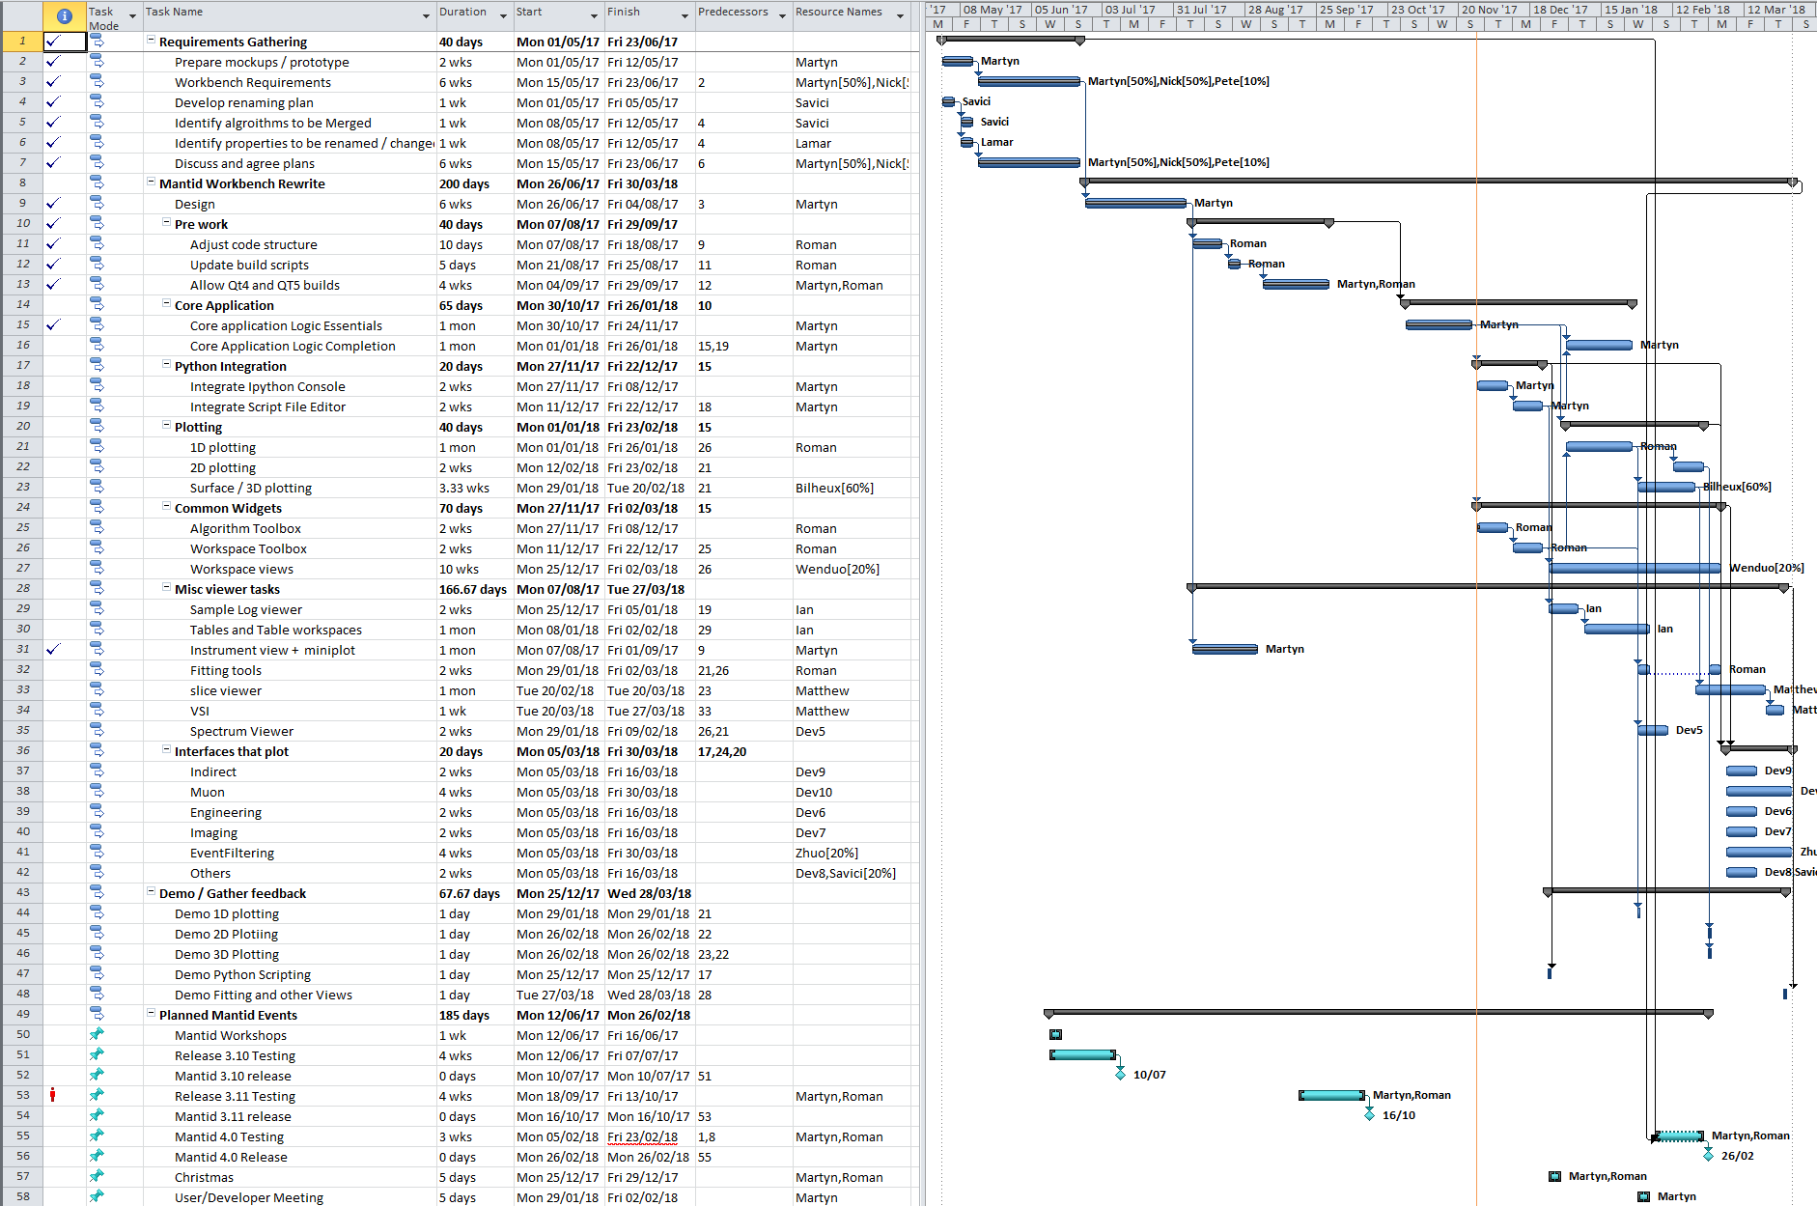

Appendix A: Metrics

Project Metrics
The code metrics are independently generated and displayed here
http://www.openhub.net/p/Mantid/analyses/latest/languages_summary

Total Lines : | 2,243,764 |  | Code Lines : | 1,606,042 |  | Percent Code Lines : | 71.6%
Number of Languages : | 17 |  | Total Comment Lines : | 350,084 |  | Percent Comment Lines : | 15.6%
 |  |  | Total Blank Lines : | 287,638 |  | Percent Blank Lines : | 12.8%

Code, Comments and Blank Lines
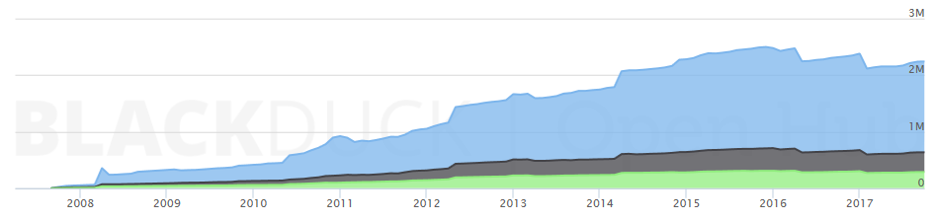
Code
Comments
Blanks

In a Nutshell, Mantid...
- has had 81,589 commits made by 124 contributors representing 1,605,793 lines of code
- is mostly written in C++ with an average number of source code comments
- has a well established, mature codebase maintained by a very large development team with stable Y-O-Y commits
- took an estimated 458 years of effort (COCOMO model) starting with its first commit in April, 2007

